AI FAQ ASSISTANT
Development and explanation
Single-file result based on the provided reference screenshots

1. Backend Development Overview
The reference screenshots describe the Backend Development stage of the AI FAQ Assistant. The backend uses Node.js and Express with database connectivity, middleware, JWT-based security, API routes and centralized error handling.

2. Gateway Server – src/server.js
The gateway server is the main entry point. It connects to the database before starting the HTTP server and reads the application port from the environment.
const app = require('./app');
const connectDB = async () =>{
try {
const dbConnect = require('./config/db');
await dbConnect();
} catch (error) {
console.error('Failed to connect to the database:', error);
}
};
const startServer = async () =>{
await connectDB();
const PORT = process.env.PORT || 5000;
const server = app.listen(PORT, () => {
console.log(`Server running in ${process.env.NODE_ENV || 'development'} mode on port ${PORT}`);
});
process.on('unhandledRejection', (err) => {
console.error('Unhandled rejection:', err.message);
server.close(() => process.exit(1));
});
};
startServer();

3. Gateway Express Setup – src/app.js
const express = require('express');
const cors = require('cors');
const dotenv = require('dotenv');
const errorHandler = require('./middleware/errorMiddleware');
dotenv.config();
const app = express();
app.use(cors());
app.use(express.json());
app.use(express.urlencoded({ extended: false }));
app.get('/', (req, res) =>{
res.json({
success: true,
message: 'AI FAQ Assistant API is running',
version: '1.0.0'
});
});
app.use('/api/auth', require('./routes/authRoutes'));
app.use('/api/faqs', require('./routes/faqRoutes'));
app.use('/api/ai', require('./routes/aiRoutes'));
app.use(errorHandler);
module.exports = app;

4. Security Access Middleware
The security middleware reads the Authorization header, extracts the Bearer token, verifies the JWT and loads the user while excluding the password field.
const jwt = require('jsonwebtoken');
const User = require('../models/User');
const protect = async (req, res, next) =>{
let token;
if (req.headers.authorization &&
req.headers.authorization.startsWith('Bearer')) {
try {
token = req.headers.authorization.split(' ')[1];
const decoded = jwt.verify(
token,
process.env.JWT_SECRET || 'your_jwt_secret_key_here'
);
req.user = await User.findById(decoded.id).select('-password');
if (!req.user) {
return res.status(401).json({
success: false,
message: 'Not authorized, user not found'
});
}
next();
} catch (error) {
return res.status(401).json({
success: false,
message: 'Not authorized, token failed'
});
}
}
};

5. Centralized Error Handler Middleware
The error handler provides consistent JSON responses for duplicate database values, Mongoose validation errors, invalid ObjectIds and unexpected server errors.
const errorHandler = (err, req, res, next) =>{
let statusCode = res.statusCode === 200 ? 500 : res.statusCode;
let message = err.message;
if (err.status) statusCode = err.status;
if (err.code === 11000) {
statusCode = 400;
const field = Object.keys(err.keyValue)[0];
message = `Duplicate field value entered: ${field}.`;
}
if (err.name === 'ValidationError') {
statusCode = 400;
message = Object.values(err.errors)
.map((val) => val.message)
.join(', ');
}
if (err.name === 'CastError') {
statusCode = 404;
message = `Resource not found with id of ${err.value}`;
}
if (statusCode === 500) console.error(err.stack);
res.status(statusCode).json({
success: false,
message
});
};
module.exports = errorHandler;

6. Backend API Flow
- Client sends a request to the Express API.
- Middleware processes CORS and request data.
- JWT middleware validates protected requests.
- API routes process authentication, FAQ and AI operations.
- Database services store and retrieve application data.
- Centralized error middleware handles failures.
- The server returns a JSON response to the client.

7. Expected Result
- Backend server starts successfully on the configured port.
- Database connection is established before normal API operation.
- The root endpoint reports that the AI FAQ Assistant API is running.
- Protected routes can validate Bearer JWT tokens.
- FAQ and AI API routes are registered.
- Database and validation errors are returned with suitable HTTP status codes.

8. Reference Screenshots
Reference Screenshot 1
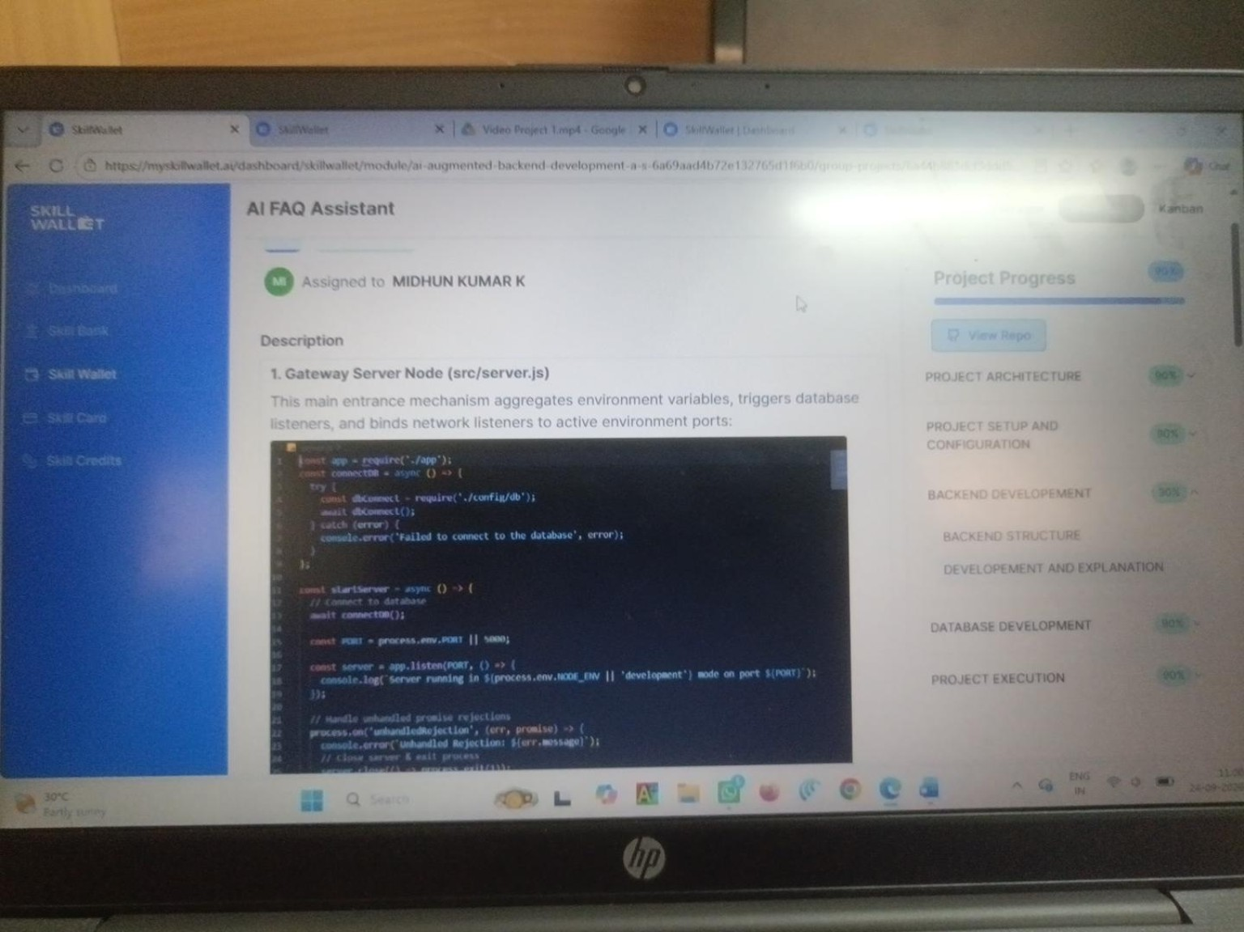
Reference Screenshot 2
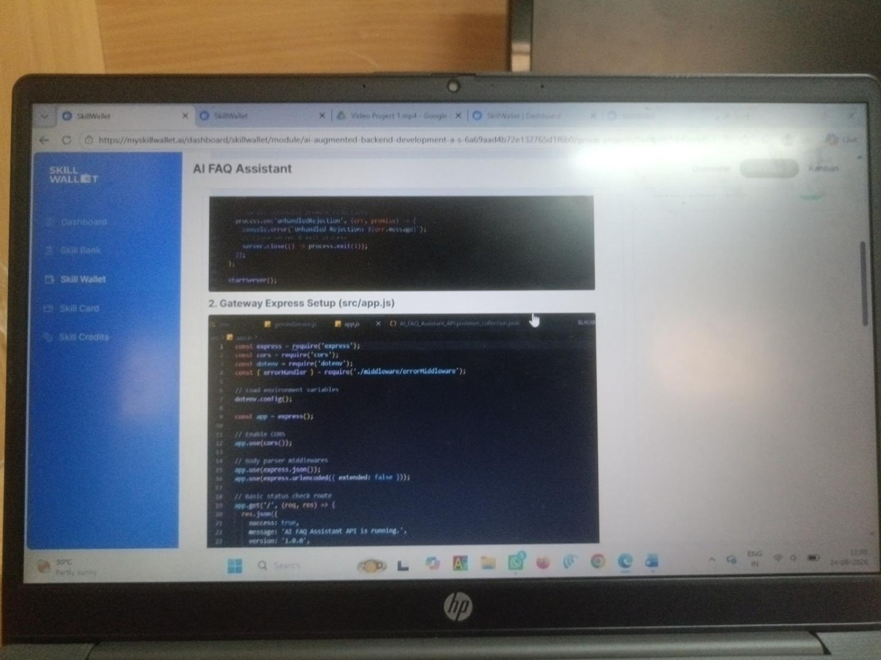
Reference Screenshot 3
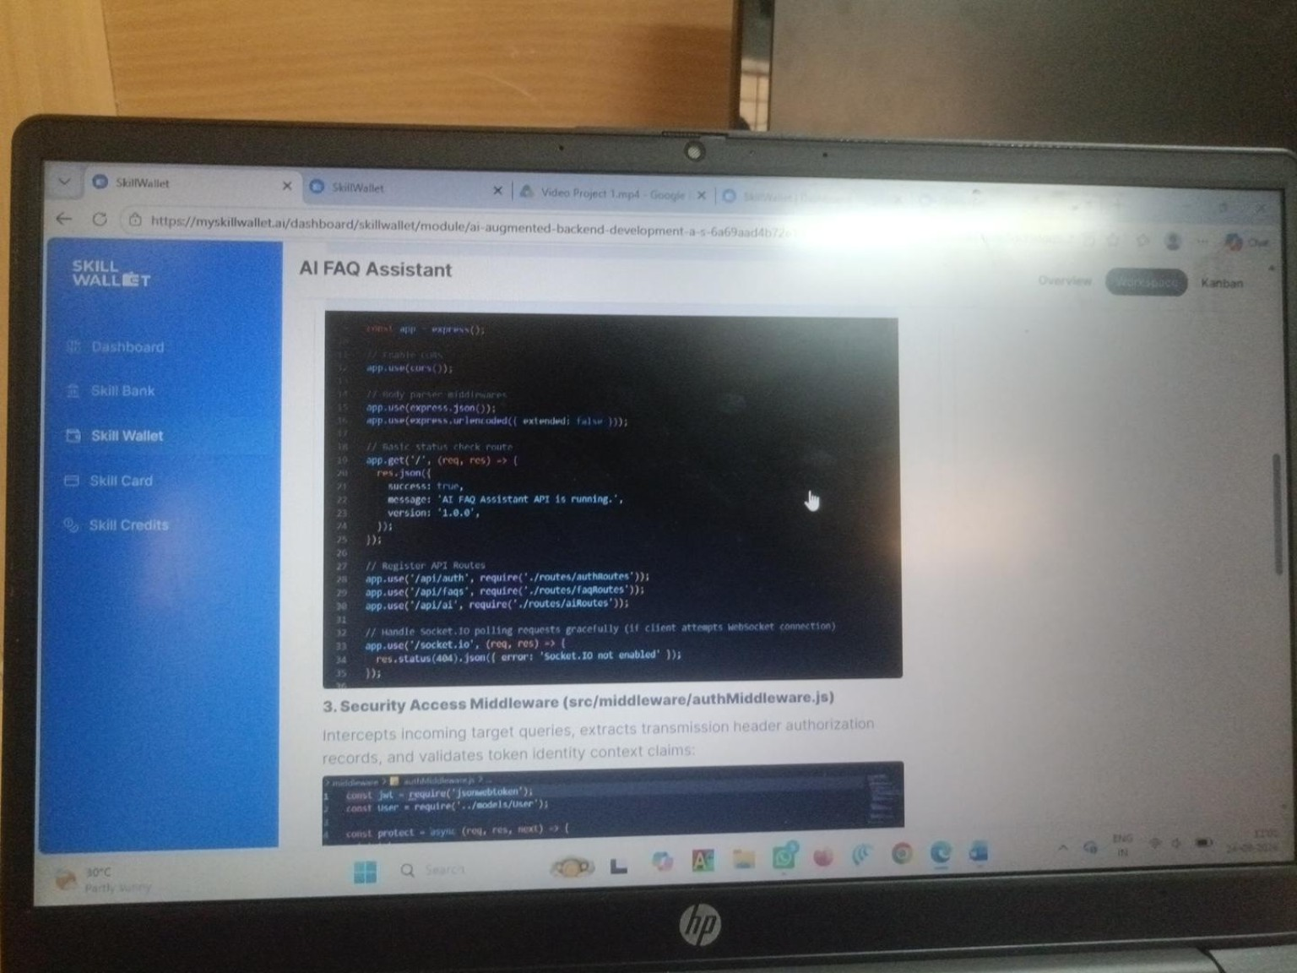
Reference Screenshot 4
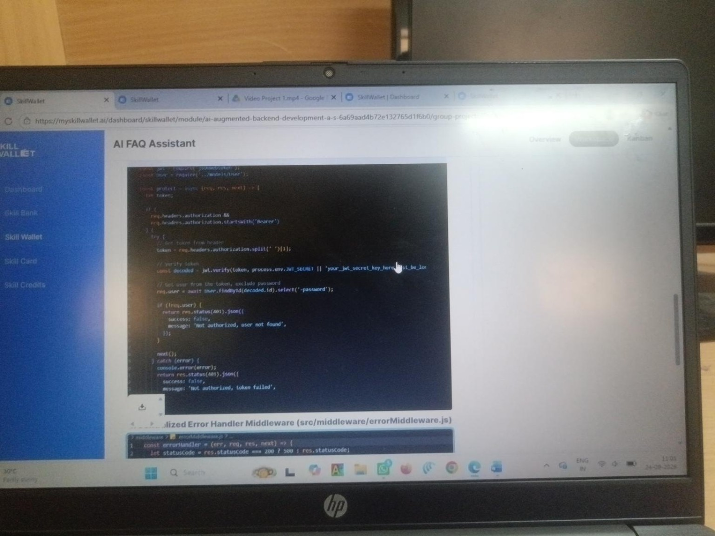
Reference Screenshot 5
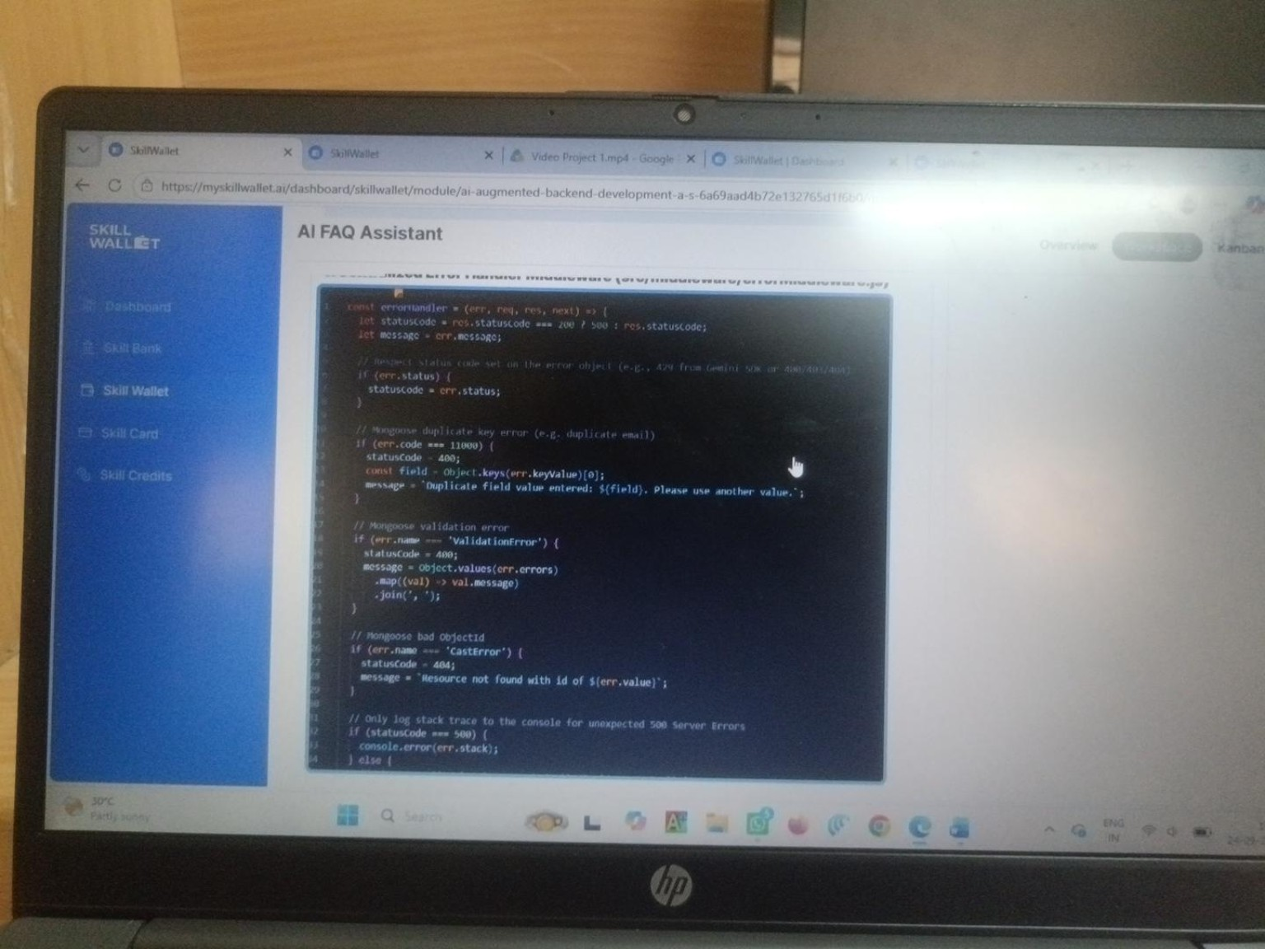
Reference Screenshot 6
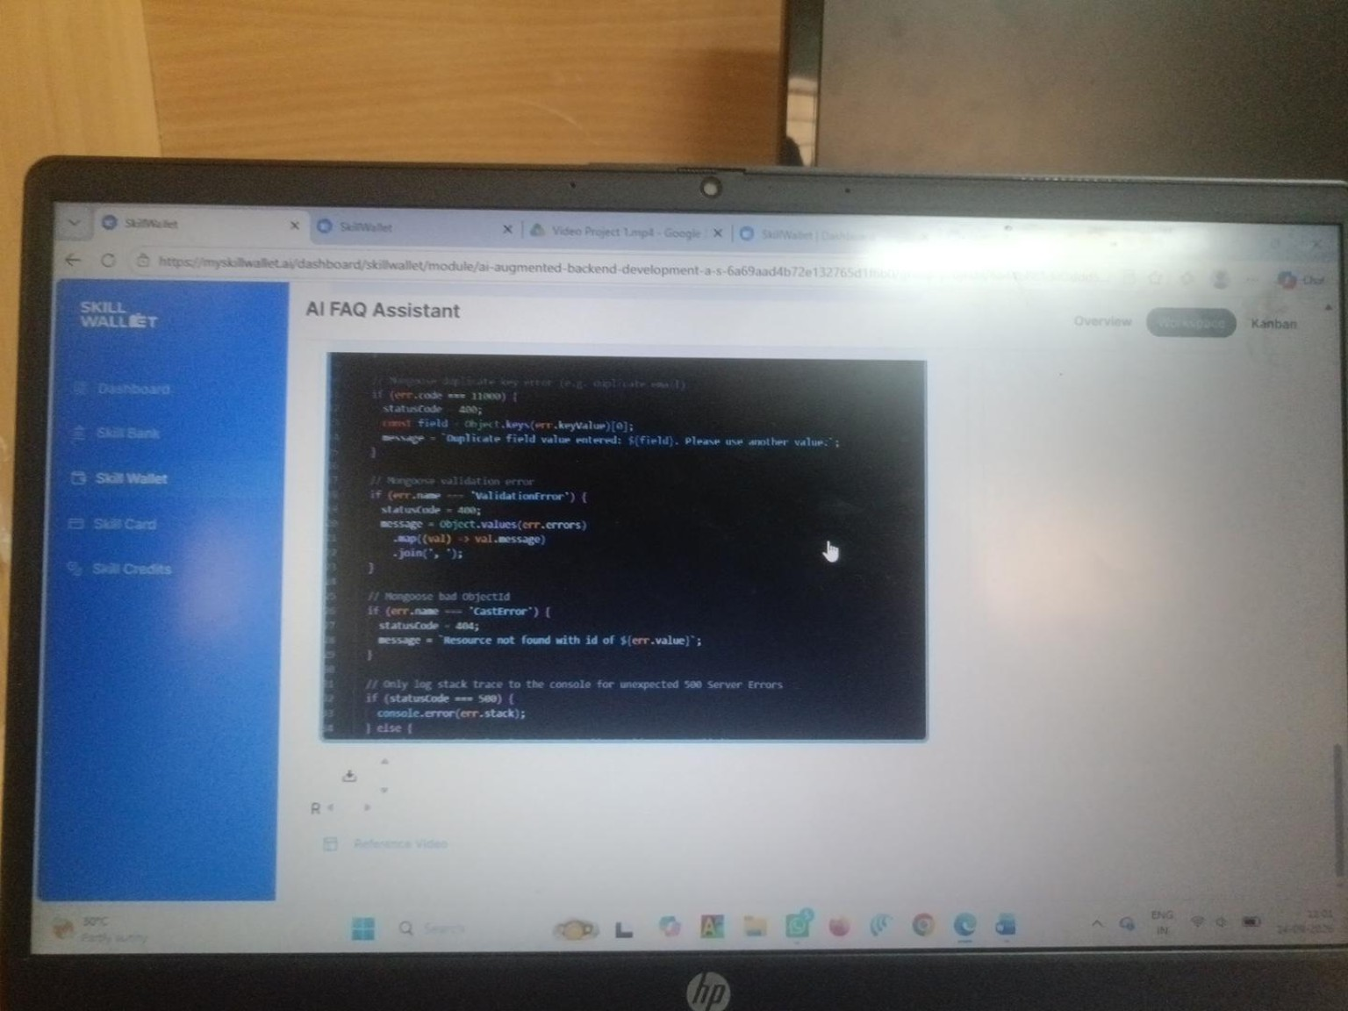

9. Final Result
BACKEND DEVELOPMENT COMPLETED – Gateway server, Express setup, security middleware and centralized error handling are prepared for the AI FAQ Assistant.

